Santiago Castro

Mass Effect 3 Multiplayer Level

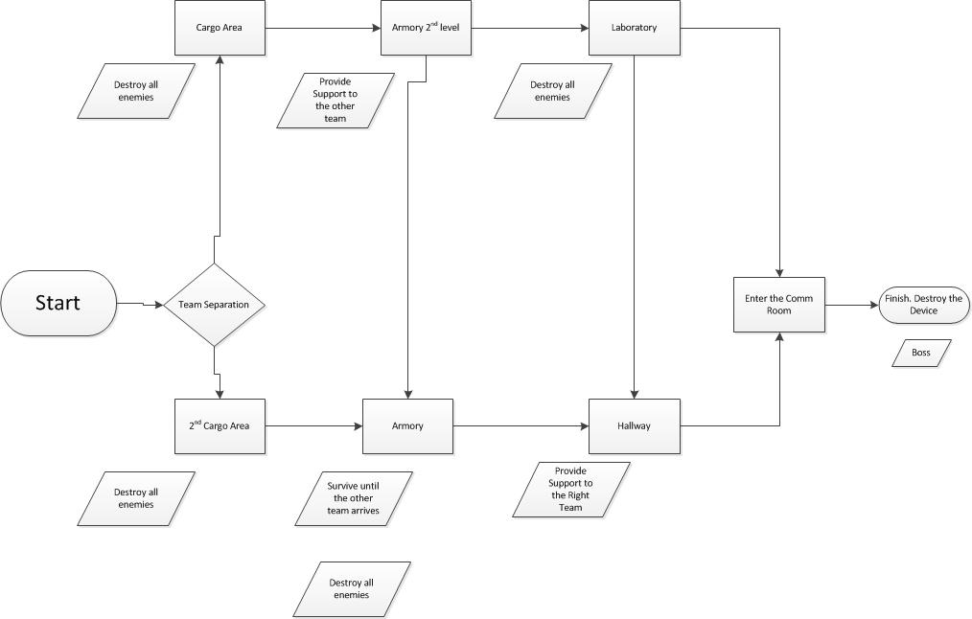

Concept:
A geth base is about to send a message to The Reapers to attack the biggest Turian military force. As member of the Special Forces, you need to work with your team and reach the geth communication console and destroy it. The base is located in a mountain base, with sections on the outside. The planet is arid and hostile to biologic beings. The based belonged to the Turian’s, but was taken by the geth. The structure is for defense, providing small windows for cover and shooting and big open areas for snipers. In the visual department, the building is upgraded by the geth. So expect to find technology that doesn’t belong to the Turians.

Overview:
The players begin the mission with a big fight at the entrance of the complex. When the battle is over, the players have to split in teams of two. A team goes to the right and the other to the left:
- Right team: This team needs to be fast in bringing support. Long Range weapons are recommended for this mission. Also the team is required to fight a mayor amount of enemies, biotic powers are preferable. The left team is able to provide back up near the end of the mission, but is a lot more limited.
- Left team: The players will fight more powerful enemies and in short range, Vanguards and Soldiers are especially effective in this section. They will provide support to the other team, in short range; shotguns are very effective in this area.

In the communication room, both teams will fight a boss protecting the communication. The players have limited time to finish this boss and prevent the message to be sent.

The players must communicate before starting the mission. Because after the first encounter, they will be able to send basic messages: to know when you are in danger and when a team has changed of room. The objective interface will provide assistance to the player and locate the other party members. This will enable the player to succeed with minimal communication.

Level Layout

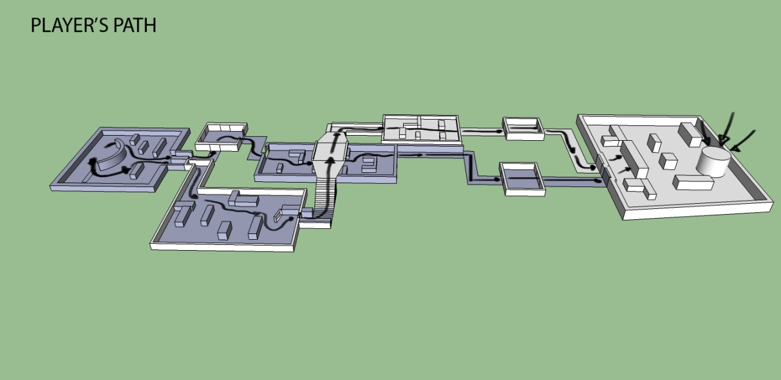

Objectives:

- Defeat the first assault and divide the teams before the time runs out. (Challenge: 5/10)

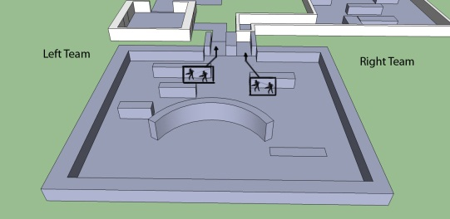

Right Team
    - Destroy the battalion and the Collosus to advance in the next chamber. (Challenge: 6/10)
    - Provide support to the left team from the rooftop. And destroy the enemy colossus and heavy Tanks. (Challenge: 7/10).
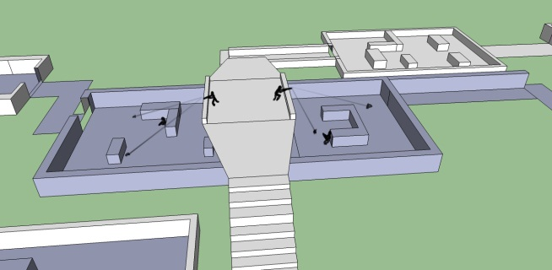

    - Survive for 5 min and destroy the remaining geth. (Challenge:7/10)
    - Open the door to the comm room.
    - Destroy the geth prototype and the communication module. (Challenge: 8/10).

Left Team
    - The players start by taking a little team of geth in the next room. (Challenge: 3/10)
    - As they continue, the team must face an enormous amount of geth and a colossus.(Challenge: 6/10)
    - The players need from the right team to defeat the geth army.(Challenge:5/10)
    - In the corridor, the team must support now the right team by covering their backs from the side. (Challenge:7/10)
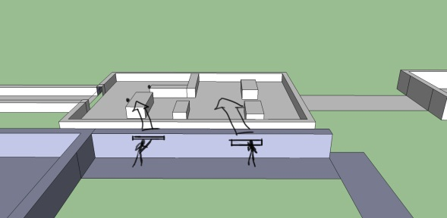
    - The next room is the switch to open the communication room.

- Open the door to the communication terminal.
- Defeat the boss and stop the message, by destroying the communication device. (Challenge: 10/10).

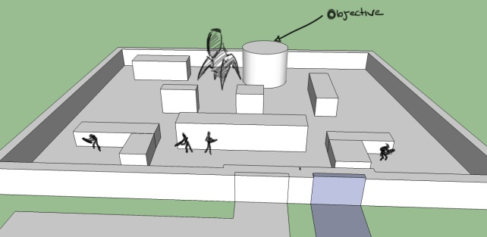

Beat Chart

Potential Risks:
- Requires online multiplayer
- Communication is preferred

Level Beats:

- Objective 1: Destroy the first geths
  - Section 1: Arriving to the base
 | Requirements
Department | Asset | Note
Art | Mountain terrain and Base entrance | Big landscape
Audio | Metal moving (door), shots
Audio | Dialogue for division

  - Section 2: First contact
 | Requirements
Department | Asset | Note
Art | Inside military base (indoors) | Science fiction interior, lights and things moving
Engineering | Geth AI, online Gameplay | No Lag online
Audio | Bullet and weapons, Geth voiceover | Geth_Effect.FILE

- Objective 2: Right: Support the other team. Left: Kill the colossus and the geth
  - Right
 | Requirements
Department | Asset | Note
Art | Corridor in top of the Left team | FILE_NAME.FILE

  - Left
 | Requirements
Department | Asset | Note
Art | Outdoor base terrace | Futuristic building, generators
Audio | Weapons, geth

- Objective 3: Right: Provide support against the geth army. Left: Destroy the geth army advance.
  - Section 1: Left
 | Requirements
Department | Asset | Note
Art | Inside a power supply room. | Energy Batteries
Audio | Support call and Geth | FILE_NAME.FILE
  - Section 2: Right
 | Requirements
Department | Asset | Note
Art | Inside a power supply room. | Energy Batteries
Audio | Support call and Geth | FILE_NAME.FILE

- Objective 4: Boss Fight and Destroying the Communication Module
  - Section 1: King of the Hill

 | Requirements
Department | Asset | Note
Art | Boss, Communication office | Big space for boss fight
Engineering | Boss behavior
Audio | Mission dialog, boss noice | Mission_Ending.FILE BOSS

